**Module 3 – ServiceNow Development Modules**

UNDERSTANDING DOCUMENT

**What is ServiceNow**

ServiceNow is a Cloud based platform, which was mainly developed for workflow and process automation as per the ITIL principles. It is a (APaaS) Application platform as a Service based platform.

**Services of ServiceNow**

Services of ServiceNow are :

1.IT Service Management : It is the most basic and important service for every company almost every company uses it. It is foundation for any services in service now . Almost all other services are also built on top of ITSM.

2. HR Management : Human Resource Management is on top of ITSM itself , it mostly deals with Onboarding and Off boarding of resources .

3.GRC :  GRC means Governance, Risk, and Compliance (GRC) it is a set of applications that help organizations identify and manage risk. It is mostly belongs to banking sectors.

4.Intrgration : Integrations is a place where we connect systems together , for transferring of data .

5.IT Asset Management : It involves in managing the assets of the organization.

6.Finance Operation Management : It manages the financial sector and financial operations of the organization.

7.IT business Management : It deals with the business , that what this business is going to do.

**How to get free SNOW instances**

We have to enter developer.servicenow in any browser and fill all he details and register then get email credentials and signup and start building in the developer instance which we will be redirected after activating it from our Gmail. If the instance is inactive for 10 days, then the instance is released ,so we need to release the instance for using it and If our instance is inactive for more than 24 hours, then your instance may go into hibernation state then we need to wakeup the instance.

**How to become a SNOW developer & ServiceNow certification training**

We need to have a bachelor’s degree and should have basics of javascript & ITIL basics and get enrolled in ServiceNow Course and give certification exam and get certificate.

**ServiceNow components & ServiceNow UI overview**

The Components are the basic elements of your page. Components range from the basic elements like labels, and buttons to more complex experience components like lists and forms. These components can be added to your page to create or personalize your workspace or portal like theme, banner, notifications, etc..

**Banner Frame:**

It the top most section which consist of the logo, which is customizable and can be used as home button, user menu which provides options like Profile, impersonate user to switch the user, elevate role for high impact actions and logout option, banner frame also contain Tools like global search, chat, help desk and system settings which has theme, accessibility, list and form, notification and developer settings.

**Application Navigator:**

Application navigator contains a Navigation filter which filters list of applications, All Applications option where all applications can be accessed and a history tab for previous searches and a favourite tab which consist of the favourites we add.

**Modules**

Some of the modules in ServiceNow are:

Incident Management, Problem Management, Change and Release Management, Request Management, Asset and Cost Management, Walk-Up Experience, Agent Workspace, Now Mobile, etc.

Request Management is basically requesting something like a item, request can be pulled from demand, so we can order something like a hard drive when we order a request number will be sent. So basically we have the above mentioned modules for providing service.

**Incident module**

Incident means interruption to the service. If we have any issue we complain it so the service provider will raise a ticket and send incident number to us and assign the task to the assignment group to resolve it.

An incident is a situation where normal service operations are interrupted, disrupted or degraded. In ServiceNow, an open incident indicates that the customer is strongly affected or it represents a business risk. The process of managing the incident lifecycle is called as an Incident management.

We can access incident through application navigator by searching incident, we can create a new record or see the existing records, we can create by clicking new and entering the details which are asked for. After this incident will be raised and assigned to the concerned person and later it will be resolved and we can close the record after resolving the issue.

**Problem module**

A problem is a cause of one or more incidents. The process of managing the lifecycle of all the problems that arises or could arise in an IT service is called as Problem management

If the same incident problem is repeating again and again then it is called as a problem, we can create a problem by right clicking on the banner of form of the incident then clicking create problem or else just go to application navigator and search problem there we can find it. Then we have to enter the details in new, then click assess it will open Assess, then click confirm to open Root case analysis, then click fix to open fix in progress, then click resolve it will open resolved tab and after that by clicking complete problem will be closed.

**Change module**

A change request contains detailed information regarding the change, like the reason for the change, the risk, the priority, the change type, and the change category. A systematic approach for controlling the life cycle of all changes, making it easier to make beneficial changes with less disruption to the IT services is called ServiceNow Change Management.

When some thing went wrong while testing then change request will be sent to change those mistakes. We can access it by searching change in the application navigator and create by opening new record. In change management the lifecycle goes like new, then it will be assessed and then authorized then it will be scheduled next it will be implemented and goes for review if it is resolved then it will be closed and cancelled, in additional information we will be having planning, schedule, conflict, notes and about closure information.

**List**

List displays record from data table like incident, problem, etc.. There are different elements in list like title bar which consist list control menu which consist of view, filter, Group by, show, refresh and favourites. It has name of the table and a search bar for searching specified content. A activity stream icon which tracks activity of the table and a navigator to jump from pages, header consists a personalize list, condition builder, breadcrumbs, sort indicator, and column headings and the Data is presented in tabular format which consist of rows and columns basically these rows are the records and the columns are the attributes.

**Growth & Major Customers**

The growth of servicenow is unbelievable, when it was started in 2004 the share price was around $0.85 from there it has came a long go now it’s share price is around $840. It has undoubtedly created a revolution of low code or no code almost all the big MNC’s are using servicenow.

Major customers of ServiceNow are intel , facebook , twitter, Capgemini, dolby, qualcomm, Netflix, etc..

**ServiceNow Architecture**

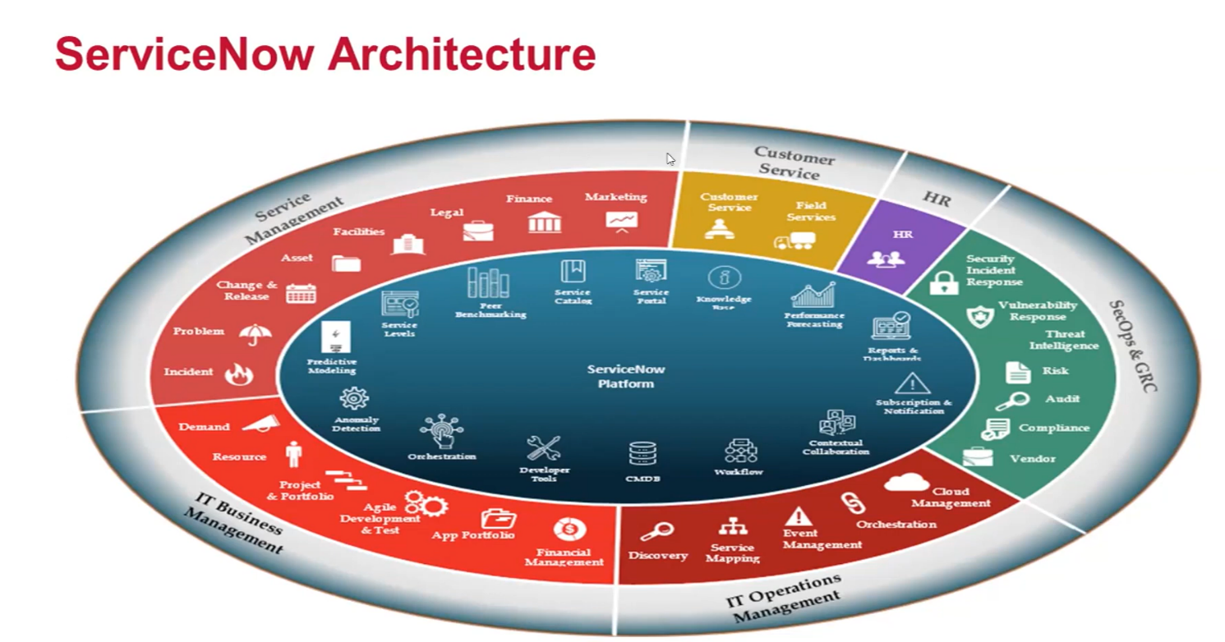

This is the architecture of ServiceNow, It includes ITSM,HR, GRC & Secops, IT business & operations Management. Where ITSM is the base or foundation for all other services. HR deals with the Onboarding and Off boarding of resources, Secops means Security operations and GRC means Governance, Risk, and Compliance (GRC) it is a set of applications that help organizations identify and manage risk. It is mostly belongs to banking sectors, IT Operation Management involves in managing the operations related to the organization.IT business Management deals with the business , that what this business is going to do, Customer Services deals with the services related to the customers sector issues.

Earlier the architecture has only ITSM but later on thigs getting updated and later many things one by one have been added like HR, Security operations and GRC, etc.. for more productivity and functions related to the Organization with Low code or No code.

**Catalog**

Catalog is like any E-commerce website like amazon, where we can order items or add items but the user interface is quite different. Service Catalog is a request ordering system for services and products of any organization. It is a One stop shop to request different services provided by all the departments of Organization it is like a Categorized items help users to request the right Service and Multiple Catalogs can be created.Key Components of ServiceNow Service Catalog are Order, order form, ordering process.

**Dashboard**

Dashboard is a visualization tool where we can visually see or track and understand the data easily and it helps in better decision making. We can access it through application navigator, just search dashboard we get dashboard which are available and we can click on create so we can create dashboard which has many demos if we click it will be opened in a new tab there we can enter the data for which we have to make dash boards, we have many templates for dash boards like we can create it for like incident, change, etc.., and we have many formats like pie charts, bar graphs and etc.. We can add widgets in custom dashboard.